From: https://medium.com/the-long-now-foundation/the-largest-early-world-map-is-unveiled-for-the-first-time-ec42a23a6933
OnJuly 25, 01585, near the end of a century of unprecedented change, four Japanese boys stopped in Milan on their way back home to Japan. They’d been sent as the first Japanese Embassy to Europe three years earlier by the Jesuit missionary Alesandro Valignano. Their European tour took them through Spain, where they met King Philip II, and to Rome, where they met with the Pope. Now, in Milan, they encountered Urbano Monte, a gentleman scholar from a wealthy Milanese family whose interests had lately turned to geography. Writing about meeting the Japanese boys, Monte “commented on their appearance and manners; the former he found odd but he thought their manners impressive and their eating habits fascinating.”
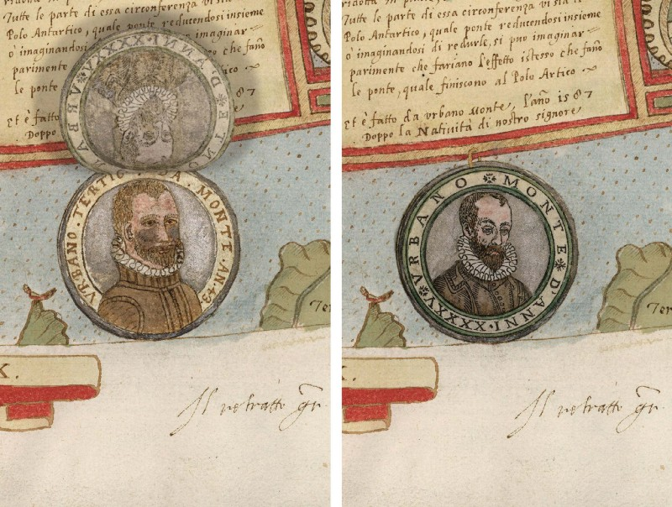
Detail of Tavola XXXXII (Antarctica, Urbano Monte Portraits of 1587 and 1589).
The encounter with the Japanese embassy inspired Monte to undertake an ambitious project that would consume his efforts for the next twenty years: the Trattato Universale, a four-volume compendium and geographical treatise that attempted to showcase the entire geographic knowledge of the world. The third volume of the Trattato contained his most impressive and innovativework: a map of the world across sixty individual sheets that, were it to be stitched together as his instructions dictated, would be the largest world map made in the sixteenth century.

………

Much more here: From: https://medium.com/the-long-now-foundation/the-largest-early-world-map-is-unveiled-for-the-first-time-ec42a23a6933

……….
It is an unusual and remarkable map, far ahead of its time. Now, thanks to advances in technology, and 430 years after it was first envisioned, viewers can finally see the world as Urbano Monte intended. The map is viewable online and to visitors to the Rumsey Map Center.

Learn More:
- In December 02017, Chet Van Duzer began a three-month research fellowship at the Rumsey Map Center to study Urbano Monte’s map. On February 23, 02018, Van Duzer will present his findings in a talk, “Making the World Go ‘Round: How Urbano Monte Created His Map of 01587.” The talk is free to attend, but registration is required.
- Explore the Rumsey Map Center’s digitized version of the Urbano Monte map.
- Watch David Rumsey’s 02004 Long Now talk, “Mapping Time.”
- Read a joint publication by Barry Lawrence Ruderman Antique Maps and the David Rumsey Map Center on the Urbano Monte map.

The Long Now Foundation is a San Francisco based non-profit that works to promote long-term thinking. We are perhaps best known for building a Clock that will last for 10,000 years. Long Now members help make all we do possible. Learn more: https://longnow.org/membership/
- Maps
- History
- Culture
- Cartography
- Technology

